Combustion Model vs Discrete Model

All processes were simulated assuming the initial mass fractions of

Cellulose – 0.4

Hemi-Cellulose – 0.3

Lignin – 0.3

Char – 10^-6 (need to assume some initial concentration, since it is a part of the rate equation)

Temperature – 600oC

The first Graph is the prediction of the combustion model (red) and pyrolysis (blue) second is char oxidation alone.

Oxygen concentration assumed to be same as atmospheric concentration.

Results

* The final concentration predicted is similar in both models.
* Water vapour concentrations are roughly the same in both models, therefore it implies that in the presence of enough oxygen we need not consider char oxidation reaction with water.

The concentration profiles of other gases like methane etc. were not calculated since they are not affected by char oxidation reactions.

Carbon Dioxide:

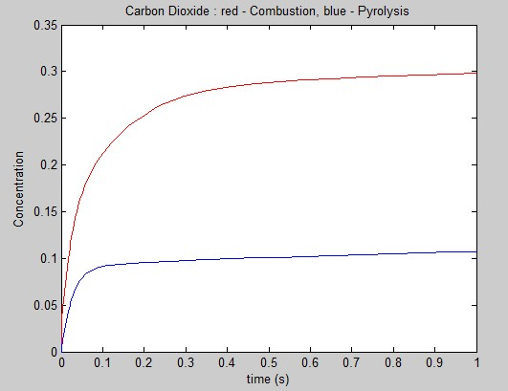

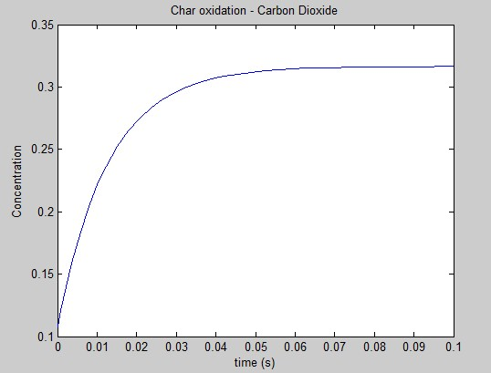

Carbon Monoxide:

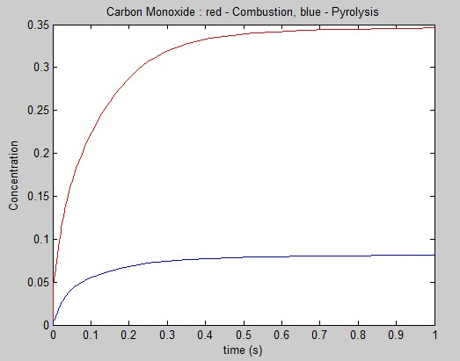

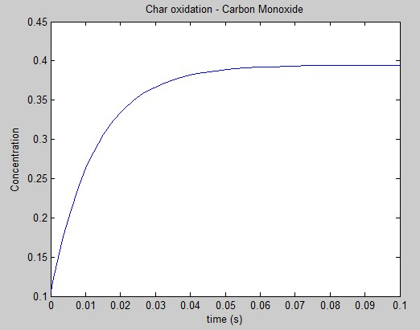

Water Vapor:

